Curriculum Vision Statement

The Bigger Picture

International education comparisons based on narrow skills will become increasingly meaningless. We need to champion a new kind of learning; one which values teamwork, creativity and the diversity of opinion held within our classrooms. We need to educate our children to think more critically, more ethically and become more geo-politically aware. (Global Challenges Insight Report: The Future of Jobs 2017)
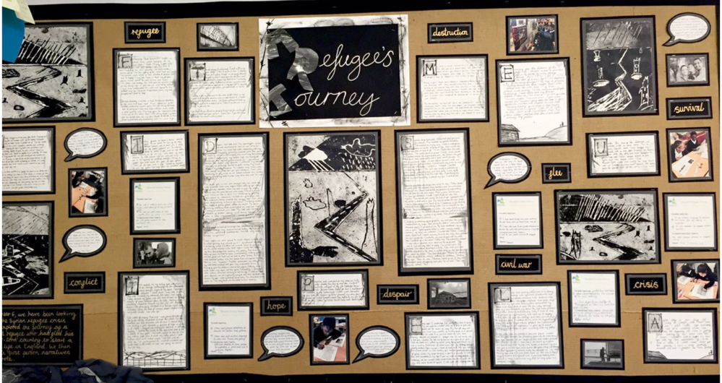

At the Inspire Partnership we recognise the circumstances facing us represent a unique configuration of challenges, which makes it essential we are proactively changing the world through learning. Employers are calling for education to expand its focus beyond the traditional cognitive domain. A recent survey by PwC indicates the need for schools to increasingly emphasise teamwork, resilience, creativity and mindset. Additionally, a report by the OECD Education in 2018 highlighted the fact that employers are increasingly preferring to focus on soft skills as part of their recruitment processes.

Alongside the need to ensure our education system is preparing children for the future, sits the desire to make our world a better place. You can’t have a good education system in a bad world. Key findings from the Varkey Foundation Generation Z report shows that young people in the United Kingdom have amongst the lowest levels of physical and emotional well-being in the world, and are amongst the least likely to think it is important to contribute to wider society. Importantly however, young people want schools to provide the skills to help them make a bigger difference and have faith in education to create a better world.
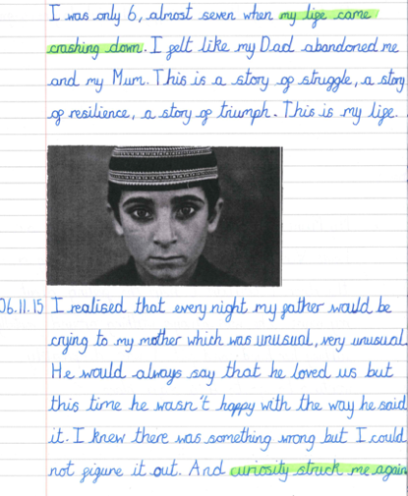
This calls for us to think about our curriculum differently. If we want learners who can thrive in turbulent and complex times, apply thinking to new situations and change the world then we must re-imagine learning: what’s important to be learnt, how learning is fostered, where learning happens and how we measure success. We want our children to understand and be present in the world.

Responding to the Bigger Picture
The Inspire Partnership curriculum is underpinned by education for global citizenship. We believe that learners are entitled to an education that equips them with the knowledge, skills and values they need to embrace the opportunities and challenges they encounter; creating a future that they want to live in. Learning is brought to life through current contexts that connects to our children’s lives - who they are, how they fit into the world and how they contribute back.
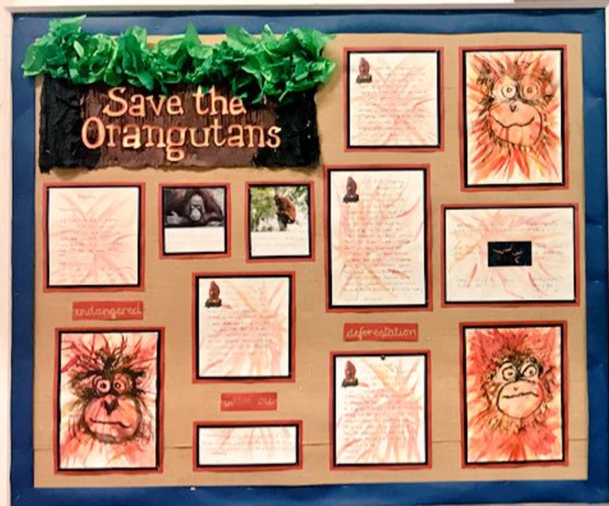
Our curriculum connects to real life, promotes thinking as a global citizen and develops character skills for young people to make meaningful contributions to society. Even very young children are trying to make sense of a world marked by division, conflict, environmental change and extreme inequality and poverty. It is designed to enable children to make deep connections between learning and understanding the world that they live in, leading to children connecting taught knowledge and skills with agency and purpose.

Therefore, we ensure learning is ‘deep’ rather than shallow. Deep learning requires planning for and modelling behaviours and actions associated with:
- deeper thinking
- deeper purpose
- active and collaborative engagement so that children meet the world but are not at the centre of it. (Please refer to the visual below)
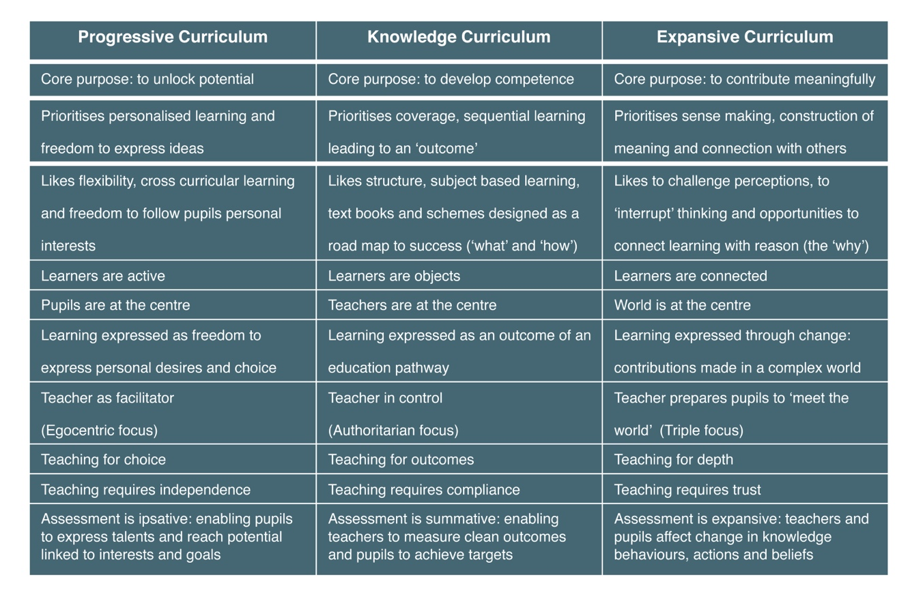

We see our curriculum as a vehicle for connecting with the bigger cause. This means we enable children to form meaningful relationships with their learning, see patterns and apply skills into a context where learning can make a difference. Children see that their learning has human significance. They understand that their global learning is relevant to future decisions and the active contribution they can make to the world. Our aim is to teach our children how to live, as well as how to learn with collaboration being at the heart of our design for learning. Therefore, the importance of curriculum design for providing opportunities to connect learning with the world is imperative. Deep learners connect what they learn with a bigger cause.
Curriculum Implementation
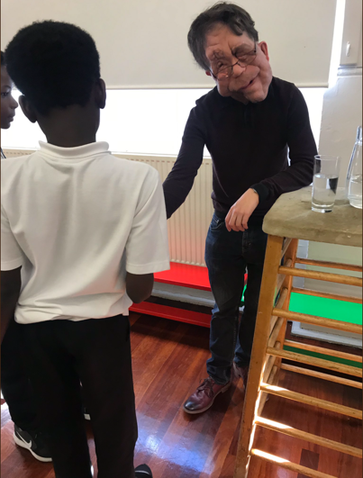
Six global learning themes underpin our curriculum and each theme is broken down into knowledge and understanding, skills and attitudes:
- Social justice and equity
- Identity and diversity
- Sustainable development
- Peace and conflict
- Human rights
- Power and governance

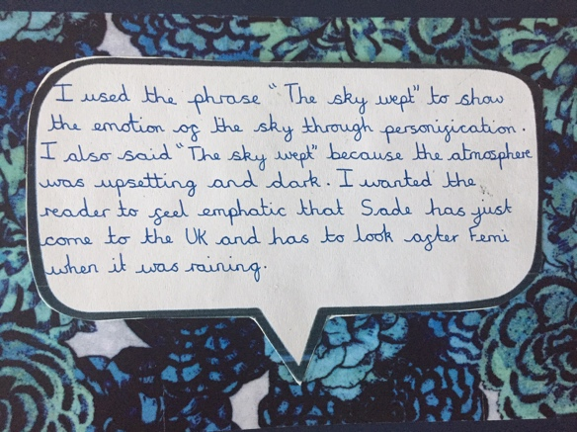
In order to achieve depth of thinking and learning we plan for children to focus on three of these themes per year. Across each year a number of high-quality core texts are used to bring the themes to life for our children and to promote a connectedness with the learning.

To allow for deep seeking meaning we ensure that our curriculum promotes learning for both their cognitive domain and affective domain (see visual below). Through our knowledge, understanding and skills we aim to develop our children’s cognitive capacity including application, synthesising and evaluating. Equal focus is given to the affective domain through our focus on values, motivations and attitudes towards learning. The values, motivations and attitudes need to be modelled and taught explicitly alongside curriculum content. We share, celebrate and pay attention to the specific learning dispositions that need to be nurtured and developed within our children.
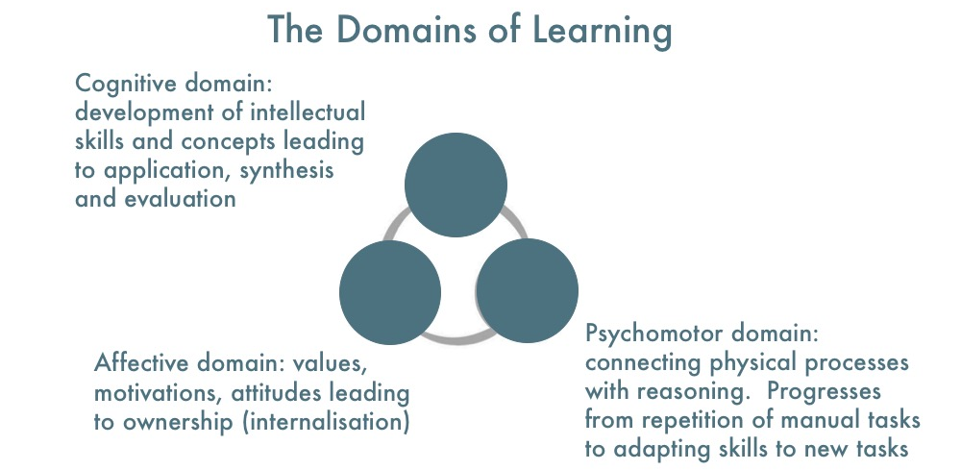

The six global themes outlined above are explored through all areas of the curriculum and across the subject disciplines.
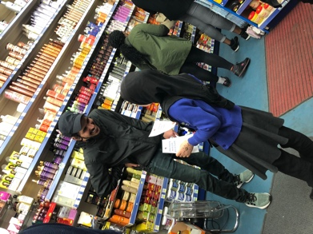
Sequences of lessons are carefully crafted around a final project outcome which allows children to become agents of change. The learning journeys are active, engaging and inspiring leading to a deeper understanding of the global themes and curriculum areas. The projects drive motivation, determination and commitment within our children. Carefully crafted sequences promote the affective and cognitive domain whilst allowing children the opportunity to develop 21st century skills such as research, collaboration, innovation, presentation, evaluation and reflection.

The curriculum promotes critical thinking skills so that children are taught to leave behind perfectly logical answers that are not solving the problem. Instead of persevering, trying to force-fit a round solution, children are able to explore a different approach and ultimately become risk takers.

When designing sequences of learning across the curriculum, we use a teaching backwards approach. At the heart of teaching backwards is a thinking process that enables our teachers to plan and teach from a clear and well-defined destination. We believe that teaching backwards is a journey that starts with the end very clearly in mind. With this knowledge, our staff design learning that focuses on small steps of progression. By slowing learning down we ensure that our focus remains on depth. Our journeys are supported at all times by high expectations.
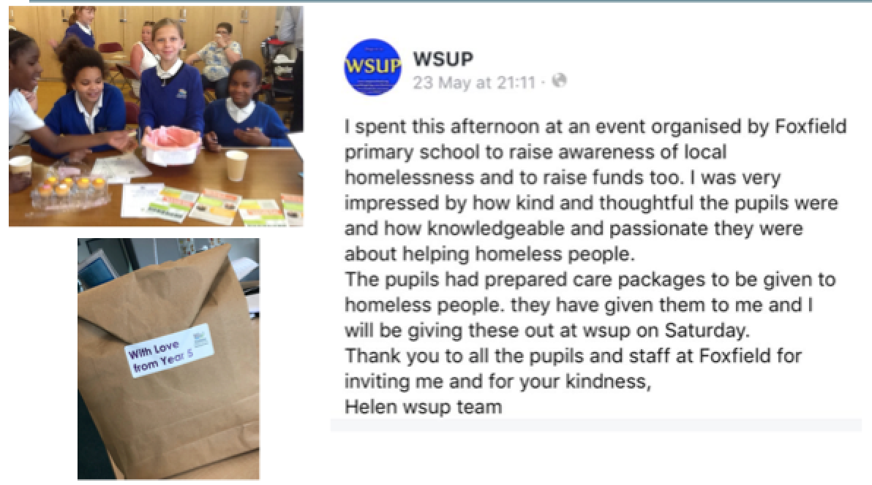

In his book ‘The Talent Code’ - Daniel Coyle argues that deliberate practice, alongside struggle promotes the growth of myelin in our brains. Struggle and practice are both key components of our teaching sequences. Well-structured modelling, highly effective questioning and carefully designed learning tasks enable children to both struggle and practice. Multiple opportunities to fail and learn from these mistakes are also central to our practice and encourage a growth mindset.
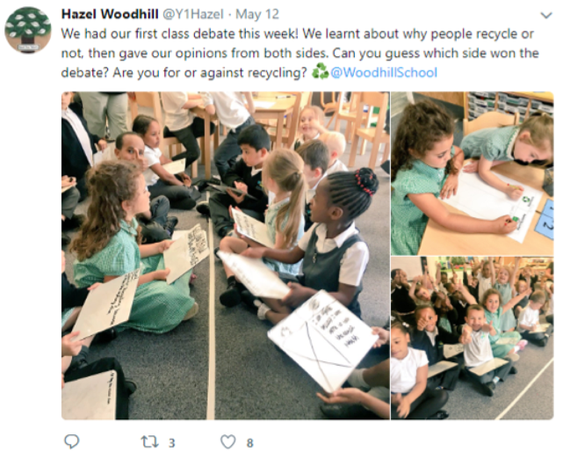
Learning is inherently a social experience. Therefore, our teaching sequences promote richly dialogic contexts that support co-construction and collaboration. Discussion, debate and communication are all valuable currency in an increasing complex world and so we plan opportunities for children to express a point of view, understanding that people have different points of view and engaging with these. Children are able to consider different perspectives and points of view on global issues and we explore the potential of being able to change one’s point of view.

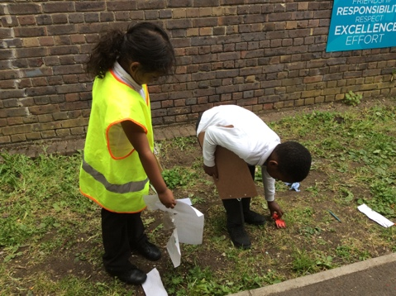
Metacognition plays a pivotal role within our sequences through explaining and reasoning, thinking about evidence, evaluating and making judgements or decisions. Through deeper thinking and reflection children are able to make links between topics so they are learning to think systematically. Teaching children how to reflect, explain, justify, question is key to lesson design.

Feedback is integrated into our curriculum design and a range of feedback types are provided throughout the sequences. Provocative prompts are used to deepen the connection with the learning and encourage children to reflect at a deeper level.
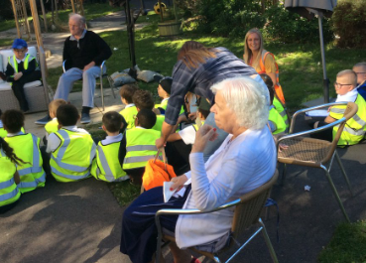
The spaces in which we spend most of our time convey important messages about what we value most. Within our schools, the learning environment is planned for in fine detail. There is a shared understanding that excellence is prized and interconnected with our school values. We do not separate the environment from our curriculum, teaching and learning or planning. We use the learning environment to communicate more than just the learning content. It represents the blending of content and pedagogy so that an understanding of how learning is organised, represented and adapted is made visible.

Curriculum Impact

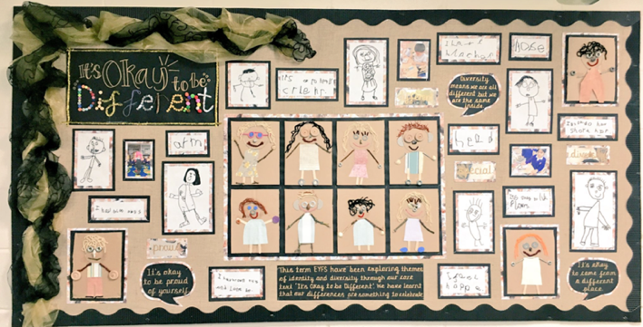
Across our trust we use regular and robust triangulated monitoring to gauge the impact of our curriculum design. Leaders at all levels review learning, talk with our children and provide feedback to move practice forward. We ensure that our children’s attainment and progress are in line or exceeding their potential. We measure this using national data (where appropriate), our curriculum maps, KPI documents and monitoring evidence. Our curriculum ensures that we develop well-rounded citizens with a clear understanding of values such as love, responsibility and friendship. Our new curriculum addresses negative stereotyping through investigating similarities and differences, and promoting acceptance, diversity, citizenship and human rights.

Learning dispositions are developed which leads to success both now and in the future. Children demonstrate greater levels of resilience, motivation and a growth mind set when faced with different types of challenge. They develop attitudes and dispositions to make a positive contribution to the world. Our daily interactions provide a regular check on this. (Please refer to visual below)

 | Characteristics | Evidence Includes
Independent  learners | Able to process and evaluate information to work out how to be successful. Able to make connections between knowledge, skills and application of learning to different tasks. Able to recognise why learning is important and has agency with learning. | - Identifies questions to answer and problem solve  - Uses research and evidence  - Explores issues, events or situations from different perspectives  - Analyses and evaluates information, measuring its value and relevance  - Filters information and uses judgement  - Justifies viewpoints to reason about learning
Creative  learners | Able to think creatively by generating and exploring ideas. Able to make connections between prior and new learning. Resilient to try new ways to tackle problems. Will share ideas and values the social element of learning. | - Generates ideas and explores possibilities  - Asks questions to extend thinking and understanding  - Connects own learning and ideas to new possibilities  - Questions presumptions about ideas and thinking  - Willing to try new solutions and adapt beliefs or ideas
Reflective  learners | Able to evaluate strengths and limitations of both self and others. Wants to help and understands the importance of dialogue as a tool for learning. Welcomes feedback and understands that learning from error is positive. Willing to modify views and make changes in order to grow. | - Will assess themselves and others considering new ways to achieve goals  - Sets meaningful and realistic targets linked to feedback  - Deals positively with praise or criticism and responds well to set backs  - Continuously evaluates learning experiences and uses learning mistakes to refine thinking, behaviours or beliefs  - Has humility
Social  learners | Able to recognise interaction with others as key to successful learning. Has a good grasp of ‘learning language’ and uses dialogue to enhance understanding. Asks questions, listens and willing to take responsibility. Able to form collaborative relationships and can resolve issues to be successful. | - Collaborates well with people to achieve shared goals  - Leads, participates and listens well during discussions  - Adapts behaviours in different situations, including showing vulnerability  - Shows fairness and consideration to other peoples’ perspectives  - Provides and receives kind, helpful and constructive feedback  - Is self-effacing
Self  learners | Able to organise thoughts, ideas and take responsibility, Willing to show initiative and commitment to the importance of learning in order to make a difference. Responds positively to new learning situations and welcomes change positively. | - Seeks out new challenges and embraces responsibility  - Is flexible to change and adapts learning to new environment or situation  - Shows commitment to learning and perseverance to complete learning  - Is able to self-organise and complete learning within time limits  - Copes with pressure and demands of learning  - Is emotionally resilient
Effective  learners | Engages actively with learning and understands the impact learning can have on self and others to enable active citizenship. Keen to participate in the life of the school and wider community and takes responsibility for improving the lives of self and others. | - Understands own learning needs and strengths  - Is persuasive in being able to justify learning decision making giving reasons and evidence  - Proposes practical ways in managing challenges of learning  - Identifies improvements to learning that have mutual benefits for all learners  - Serves as an advocate for learning, expressing diversity of opinions, views and solutions  - Is empathetic
Our children will be motivated by a strong personal sense of morality. They will be able to make sense of an increasingly globalised, complex and rapidly changing world. They will make decisions for the right reasons and in the best interests of our community. The children are more confident in speaking about current issues through collaborative learning activities. They will be able to decide what is right and what is wrong and will be resilient to the influence of others. The children develop an awareness of how their own actions can impact others and the wider community. They will go out into the world and make a difference in their own life and to others.

Pupil Voice
“I enjoyed the learning because it was true to life and happening right now.” Year 3 child

“It makes us realise we can make changes to our world.” Year 2 child

“The impact the learning has had on me is that I now know the planning process for organising an event for the community and all the steps that are needed to be followed to bring about a change.” Year 5 child

Teacher Voice

“The children had the chance to have their opinion heard and their debating skills were enhanced. The children agreed and disagreed with the MP and could articulate why.”

“There has been a much deeper understanding of the learning as the children have the chance to apply the concepts in real life situations. As a result, they have truly developed their relationships with each other, the community, and globe.”

“The children have a greater understanding of the relationship between concepts and how they can be transferred in real life. For example, in English the children were able to pull in the knowledge they had developed from curriculum lessons and apply it in their writing, without the need to explicitly teach it.”

“The children are actively involved in their learning and have become active citizens as a result of their learning being embedded in the global themes.”

Parent Voice
“For Christmas my child really wanted a doll. But when she looked at all the packaging, she changed her mind; she was worried about all the plastic in the oceans after learning about this in school” KS1 parent
“My child was playing with her cousin who attends another local school. Her cousin told a joke about slavery, which I could see made my child uncomfortable. After learning all about slavery in school, my daughter could confidently explain to her cousin that slavery was a serious issue that still exists today and is not something we should be making fun of” LKS2 parent

